ATOMIC BLASTERS REPORT

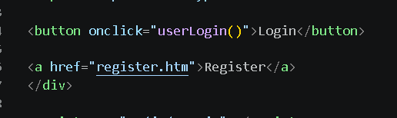
Most of the file having htm ,It should be html

—-------------------------------------------------------------
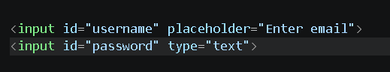

It was there in user login,admin login and in user registration. Type should be password.

—-------------------------------------------------------------------------------

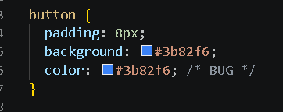

Login text is invisible in button due to same colour text and background.
—------------------------------------------------------------------------
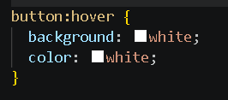

While hovering on login button ,button was turning into whole white.

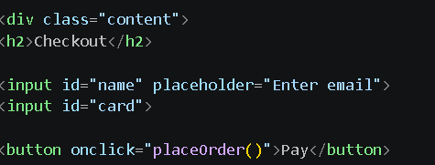

Here id is name ,but placeholder has enter mail.which asks user to enter email instead of name.

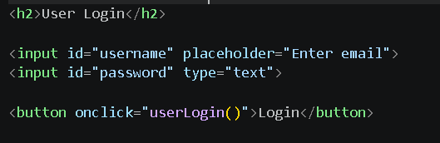
Same here instead of Enter email it should be username.

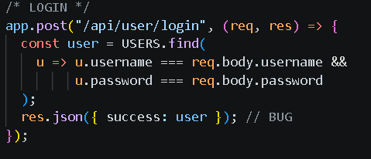
Success should be boolean

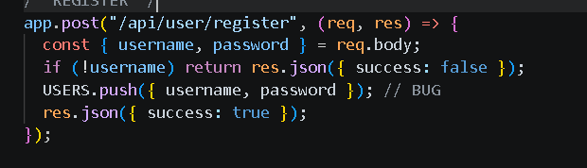

It should be username.username and password.password

Updated user - login.html

<!DOCTYPE html>
<html>
<head>
<link rel="stylesheet" href="../css/style.css">
</head>
<body>

<div class="center-box">
<h2>User Login</h2>

<input id="username" placeholder="Enter email">
<input id="password" type="password" placeholder="Enter password">

<button onclick="userLogin()">Login</button>
<button>
<a href="register.html" style = "text-decoration : none; color: black;">Register</a>
</button>
</div>

<script src="../js/app.js"></script>
</body>
</html>

Updated user-register.html

<!DOCTYPE html>
<html>
<head>
<link rel="stylesheet" href="../css/style.css">
</head>
<body>

<div class="center-box">
<h2>Register</h2>

<input id="username" placeholder="Enter email">
<input id="password" type="password" placeholder="Enter password">

<button onclick="register()">Register</button>
<button><a href="login.html" style = "text-decoration : none; color: black;">Back</a></div></body></button>

</div>

<script src="../js/app.js"></script>
</body>
</html>

—----------------------
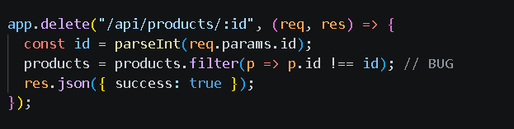

p=>p.id===id

—--------------------------------------
